**A project report**

**On**

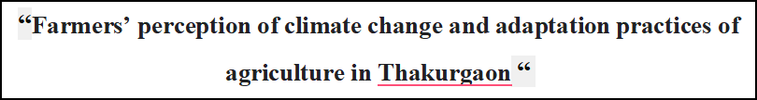

This project report is submitted to the Department of Statistics ,Begum Rokeya University, Rangpur in partial fulfilment of the requirement for the Degree of Masters of Science (M.Sc) in Statistics



**Course code: STAT 5209**

**Course Title: Project Report**

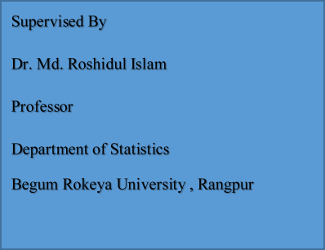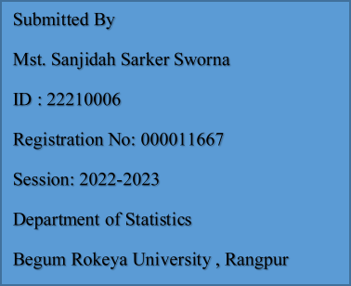

**Department of Statistics**

C:\Users\USER\AppData\Local\Temp\ksohtml20604\wps6.png **Begum Rokeya University , Rangpur**

**Abstract**

The study aimed to understand overexploitation, potentiality of groundwater for irrigation in Barind area and its probable impact on environmental. The study area was Chapai Nawabganj district in Barind area located in North-western part of Bangladesh. The study area consisted of five Upazilas in the district, namely Nawabganj, Shibganj, Nachole, Gomastapur and Bholahat. The study has considered secondary data collected from different organizations and five boring log samples were collected from five Upazilas of Chapai Nawabganj district in Barind area. A total of 50 representatives deep tubewells (DTWs) water samples were collected from 5 selected locations of each Upazila during the month of March (pre-monsoon) and October (post-monsoon), 2014. The experimental data were statistically analyzed using various software and the results were discussed to interpret the geochemical characteristics, water type, and water quality. The study results illustrate that the highest groundwater depletion was about 29 m found at Nawabganj Upazila in 2010 and the lowest was about 5 m at Shibganj in 2003. A 10-year rainfall data of the district showed that the maximum annual rainfall recorded was 1804 mm in 2007. Since then, rainfall was gradually decreasing for consecutive three years, but it was again increased 439 mm in 2011 from 1015 mm recorded in the previous year. The highest annual rainfall received in the area was 1793 mm in 2007 and the lowest was 1025 mm in 2010 in the district. The average rainfall received in Chapai Nawabganj district was 1372 mm during 2002-2011. The estimated run-off and infiltration results of Chapai Nawabganj district in Barind area illustrate that decreasing trends in run-off and infiltration were observed for consecutive three years since 2007, but they were increased in 2011 in all Upazilas due to higher rainfall received. The analysis results show a good relation among rainfall, infiltration and run-off indicating that the higher amount was the rainfall, the higher amounts was the estimated runoff and infiltration.

**CHAPTER ONE**

**INTRODUCTION**

* 1. **Background**

Groundwater is a vital source of water through the world and Bangladesh. About 30% of the earth fresh water stores in underground aquifer (The Encyclopedia of Earth, website). It is the purest form of water and as its stores in underground for long periods and it can be available at a small capital cost and its value to mankind is unlimited. It is also flows over long distances through the aquifers and it is available to a very large number of people at their firms. The infiltrated water after meeting the soil moisture deficiency percolates deeply and becomes groundwater. The groundwater is free from pollution and is very useful for domestic use in small towns and isolated farms. In arid regions, ground water is often the only reliable source of water for irrigation. It could be wisely managed and protected against undue exploitation and contamination by pollutants or salt water. The potentiality of groundwater attracted the attention of agricultural engineers, civil engineers, geologists, geophysicists and scientists from various disciplines (Reddi, 1986).

Groundwater is an essential source of water for humanity. Up to 50% of the world's population gets all or some of their drinking water from groundwater, which also supplies 43% of the water used for cultivation. Approximately 2.5 billion people on the planet rely exclusively on groundwater resources to meet their basic daily water requirements .Groundwater is critical to both drinking and irrigation water supplies in Bangladesh. Today, approximately 97% of all drinking water supplies comes from groundwater via hand-operated tube-wells tapping from primarily the shallow (<150 m below ground level) groundwater. (Mohammad Shamsudduha,2013) Bangladesh relies heavily on groundwater as a resource for developing its irrigation system.

Ground water is the main source of fresh drinking water and irrigation water for the northwestern part of Barind tract (Rajshahi , Naogaon & Chapai Nawabgonj district).Agriculture in Bangladesh is dependent on irrigation during the dry eight months from mid-October to mid-June when rainfall is minimum Groundwater supplies about 75% of dry season irrigation and almost all municipal water supplies ( Mohammad Ahmeduzzaman et al.,2012).Even while groundwater is essential for irrigation, it is fast running out in many partsof the world. This is especially true in the districts of Chapai Nawabgonj, Naogaon, and Rajshahi .The water level varies from 28.60-64.80 m during 2007-2016 at Nawabganj Upazila. The maximum depletion of water level was found to be 64.80 m in 2013 and minimum was 28.60m in 2011. In Shibganj Upazila, the water level varies from 27.20-6.33 mm. The maximumdepletion of groundwater level was found to be 27.7 mm in 2011 and the minimum was about 6.33 mm 2008. The groundwater level varies from 109.40-78.17 mm at Nachole Upazila forthe same period was observed. The maximum water level was observed to be 109.40 mm in2014 and the minimum was 78.17 mm in 2007. In Gomastapur Upazila, the water level fluctuated from 41.0-10.90 mm.2

It is founded that the highest groundwater depletion was about 109.40 mm found at Nachol Upazila in 2014 and the lowest was about 20.10 mm at Shibganj in 2016(Md Golam Mostafa,2018) Climate change is now one of the most burning issue in the world contest. Bangladesh is also recognized as a vulnerable zone to climate change by the international community as well as the most disaster prone country of the world (IPCC, 2014).Based on the climate change scenarios and projections, Paul (1998) described in his study that Bangladesh (especially western part) will be at risk of drought under climate change conditions. Due to the rapid climate change, it may accelerate the frequency of extreme drought events in the Barind region of north-western Bangladesh (Selvaraju and Baas, 2007).

**1.2 Scope of the research**

The groundwater potentiality of groundwater in Chapai Nawabganj district has been assessed principally considering specific yield, area and number of Deep Tubewells (DTWs)

in the study area. A number of reports showed groundwater level depletion in the area has threatened crop production in the future. Therefore a detailed research work is imperative to understand the relation among rainfall, recharge capability and groundwater level fluctuation in the area as well as to predict environmental impact due to groundwater extraction for irrigation. The study results would have a great impact on sustainable groundwater resource management which would help our agriculture sector to become more environmental friendly. This research program has considered rainfall, water level fluctuation and drilling log data, and water quality parameters of five Upazilas in Chapai Nawabganj district under the Barind tract in view of maintaining sustainable irrigation water supply to achieve food security as well as water resource management.

**1.3 Aim and Objectives**

The study aimed to characterize the existing groundwater environment and to conceptualize the impact of groundwater exploitation on environment.

The objectives of the study were to

● Calculate a preliminary estimation of run-off and infiltration.

● Evaluate the seasonal groundwater level fluctuation.

● Determine specific yield and storage capacity of the study area.

● Evaluate the seasonal variation of groundwater quality.

● Assess the environmental impact due to groundwater extraction for irrigation.

**CHAPTER TWO**

**REVIEW OF LITERATURE**

2.1 Review of Literature

The literature reports are vast as regards the most important and brilliant development of the extensive studies of groundwater potentiality, exploitation and over drawl impact. A substantial amount of investigations are related to evaluate groundwater potentiality and controlling groundwater quality based on hydro-chemistry. The following summarizes only the recent reports on the groundwater potentiality, exploitation, geochemistry, water type, dissolution of minerals etc so far published. The groundwater resource is one of the key factors in making the country self sufficient in food production. Groundwater-irrigated agriculture plays an important role in poverty alleviation and has greatly increased food production. The country’s GDP is highly dependent on the development of water resources in general. Trends indicate that farmers are becoming increasingly productive as a result of enhanced access to irrigation through groundwater (BMDA, 2000). In this Northern part of the country, lied the Barind Tract of Bangladesh, mainly and mostly in the district of Rajshahi, Chapai Nawabganj and Naogaon. This tract lies in the Northwestern part of old Rajshahi district (i.e. Rajshahi, Nawabganj and Naogaon), is dissected in the west and nearly level in the east. Mainly the central and Northern part of the old district belong to this landscape, covering fourteen upazillas (Matin, 1991). Monsoon rainfall may be defined as a complex meteorological condition which exists in any given area and important individuality to the landscape of the area. Monsoon rainfall plays important role in water resources management, crop management, planning of location of industrial cities, defense planning, tourism and transport, air pollution studies and in fact almost all spheres of human activity (Aziz, Abdullah-ul-Masum, Asma ul Husna and Matin, 2002). Warnings of a groundwater crisis (with falling groundwater tables and polluted aquifers) have led to calls for urgent management responses. However, much of the discussion has been on the basis of anecdotal evidence (Brown and Halweil, 1998; Postel, 1999; Sampal, 2000). The study of quantity of water alone is not sufficient to solve the water management issues because of its uses for various purposes depend on its quality. Hence, the hydro-geochemical characters of groundwater in different aquifers over space and time have proven to be important in solving the problems (Atwia et al., 1997; Ballukraya and Ravi, 1999; Panigrahy et al., 1996; Ramappa and Suresh, 2000). Therefore, the fundamental knowledge of the controlling process in groundwater chemistry is a pre-requisite condition for rational management of water resources. Groundwater supplied from 75 DTWs through pipe networks of 512 km reticulated over an area of 93.34 square kilometers and also withdrawn from 3811 shallow tubewells in Rajshahi City (R WASA, 2013). Groundwater water demand is increasing day by day in the City and the current water demand is likely to reach around 118,077 m3/day, where supply water is about 55,440 m3/day (R WASA) which would be 2,40,000 m3/day by 2020 (DDC, 2002). About 70% of the population has access to pipe water (supply water) and the rest (30%) of demand is mitigated through shallow tube wells in the City area (R WASA, 2013). But the most unfortunate thing is that the tap water is being supplied without any treatment. Recently a surface water treatment plant has been established at Shampur in the City which cover about 10% of the total supply water. A number of research works were carried out on geochemistry of groundwater (Balasubramanian and Sastri, 1994), groundwater level fluctuation and quality monitoring, and its suitability for drinking and agriculture purposes (Subramani et al., 2005a) and the occurrence of various rock types and their mineral composition (Subramani et al., 2005b). A number of studies on groundwater quality with respect to drinking and irrigation purposes have been carried out in the different parts of the world including Bangladesh (Lakshmanan et al., 2003; Mondal and Singh, 2004; Rabemana et al., 2005; Das and Kaur, 2007; and Sadashivaiah et al., 2008). The reports showed the analysis of major cations such as Na, Mg, K, Ca and anions including HCO3ˉ, Clˉ, SO4²ˉ, HNO3ˉ and physical parameters i.e. pH, EC, TDS and TH are important for drinking purpose. Groundwater quality determination can be evaluated by various softwares (AQUACHEM, PHREEQC etc.) and diagrams such as Chanda, Dourov, Piper, Stiff (Chadha, 1999; Durov, 1948; Piper, 1944; Stiff, 1951) etc. Arsenic is viewed as being synonymous with toxicity. Arsenic contamination in groundwater is one of the biggest natural calamities, which has become threat to human health throughout the world. High arsenic concentrations have been reported recently in the USA, China, Chile, Bangladesh, Taiwan, Mexico, Argentina, Poland, Canada, Hungary, Japan and India. Among 21 countries in different parts of the world affected by groundwater arsenic contamination, the largest population at risk is in Bangladesh followed by West Bengal in India. Arsenic is considered a highly toxic element and abundant in our environment with both natural and anthropogenic sources (Smedley and Kinniburgh, 2002). Nickson et al., (1998) reported that as many as million water wells drilled into Ganges alluvial deposits in Bangladesh and India (West Bengal) may be contaminated with arsenic. Arsenic contamination level in groundwater in many parts of the world has aroused attention due to it much higher concentrations than that of the World Health Organization’s (WHO) drinking water standard. This situation has become more serious in Bangladesh, India (West Bengal), and Nepal in the Indo-region as a result of resource pressures from growing populations as well as surface water contamination (Kanel et al., 2005; Smedley and Kinniburgh, 2002). Many studies have revealed that arsenic in groundwater, even at trace levels has proven to be harmful to human health and the environment. Hardness is very important property of water from its domestic application point of view. It is mainly an aesthetic concern because of the unpleasant taste. It also reduces the efficiency of soap and causes scale formation in pipes. Hard water also causes problem in boilers in industries however, it can be easily remove by the addition of slake lime [Ca(OH)2]. The World Health Organization did not have any recommendations for levels of Ca and hardness in drinking water (WHO, 2008). However, researchers have suggested that a minimum of 20 mg/L (Novikov et al., 1983) and an optimum of about 50 (40-80 mg/L) mg/L (Kozisek, 1992; Rachmanin et al., 1990) calcium present in drinking water may be the most suitable for human consumption. Kozisek (2006) showed that there is a higher risk of gall stones, kidney stones, urinary stones, arthrosis and arthropathies in populations supplied with water of hardness higher than 300 mg/L (Kozisek, 2006). According to WHO report (2007), 1.1 billion people lack access to an improved drinking water supply and 88% of the 4 billion annual cases of diarrheal disease are attributed to unsafe water and inadequate sanitation and hygiene, and 1.8 million people die from diarrheal diseases each year. The report also illustrate that the estimated that 94% of these diarrheal cases are preventable through modifications to the environment, including access to safe water. It is true that water borne infections are responsible for more than 80% of the diseases in all over the world. Whenever there is contamination of drinking water sources and water logging after rain there is in an outbreak of infection. Hazardous heavy metal contamination of groundwater is one of the most important environmental problems throughout the world.A number of reports were found available on the internet, journals and books about arsenic contamination of groundwater in Bangladesh, related health hazards and mitigation measures (Chakravarty et al., 2002; Chakraborti et al., 2010; Van Halem et al., 2010; Kongkea et al., 2010; Karim, 2000; Meng et al., 2001; Mostafa et al., 2010, 2011; Needleman and Gatsonis, 1990; Nickson et al., 1998;, Selim et al., 2010).

**CHAPTER THREE**

**DATA SOURCE AND METHODOLOGY**

**OF THE STUDY**

**3.1 Introduction**

This concurring chapter discuss about the selection of study area, sampling techniques, sample size, data processing, analysis, and presentation .All its board and specific objectives are fulfilled by this proper research design and method.

3.1 Data

3.1. a. Data (1) primary Data

Primary data is the data that is collected for the first time through personal experiences or evidence, particularly for research. It is also described as raw data or first-hand data.

3.2. b. Data (2) Secondary Data

Secondary data is the data that has already been collected through primary sources and made readily available for researcher to use for their own research. It is a type of data that has already been collected in the past.

**3.2 Methodology of the Study**

Methodology of the study comprises questionnaire method, direct method, direct talking with Executives and respondents, graphic representation, statistical analysis etc. Qualitative and quantitative information are collected through different media.

Basically information is collected in following way;

3.2.1 Primary source of information

3.2.2 Secondary source of information

**3.2.1 Primary Source of Information**

Primary source is the sources from where information is collected directly.

3.3 Survey Method

Survey method was used to collect data from the selected region of Barind Tract.

a) Questionnaire method

Questionnaire method is one of the most useful systems used in collecting data andinformation. Questionnaire is two type such as

i)Open ended Questionnaire

ii)Closed ended Questionnaire

b) Observational method

c) Interview Method

Interview is the method of achieving information from the respondents, in where the in-formation is gained by a conversation between interviewer and respondent. The information through interview might be achieve by various ways .some of them are:

i) Telephone interview

ii) Indirect inquiry

iii) Personal interview / face to face interview

**3.2.2 Secondary source of information**

Secondary source of information is information which has been collected by individuals or agencies for purposes other than those of our particular research study include govt. publications, seminar papers, journals , published or unpublished thesis and topic related various books, Barind Multipurpose Development Authority, BMDA ,web site etc.

Barind area is located in the northwestern part of Bangladesh consisted of most parts of six districts, namely Chapai Nawabganj, Rajshahi, Naogaon, Joypurhat, Bogra, Dinajpur and Rangpur. The area is situated in 24-23 to 25-15 N and 88-02 to 88-57 E.

The groundwater overexploitation has caused the water table depletion to the extent of not getting fully replenished by the rainfall recharge. The irrigated water exploration in the area is increasing day by day, eventually the groundwater aquifer may be exhausted that will have certain impact on environment. Considering the Barind area and its irrigation project, the study has confined at a specific part, i.e., Chapai Nawabganj district of the Barind Irrigation Project. The district consists of five Upazilas, namely Nawabganj, Shibgonj, Nachole, Gomastapur and Bholahat and it lies under the Barind tract and has an area of 1744.33 km². The main rivers of the district are the Ganges and Mahanadi.

In Chapai Nawabganj district, Shibganj is the largest (525.43 sq km) Upazilas and it occupies 30.86% of the total area of the district and Bholahat is the smallest (123.52 sq km) Upazilas of the district.

Detailed information of five Upazilas of Chapai Nawabganj District in given Table 1

Table 1

|  |  |  |  |  |  |  |  |  |
| --- | --- | --- | --- | --- | --- | --- | --- | --- |
| Name of Upazila | Area  (Sq km) | Municip-ality | Union | Mouza | Village | Population | Density  (per sq  km) | Literacy  Rate (%) |
| Nawabganj | 451.80 | 1 | 14 | 174 | 211 | 452650 | 1002 | 38.1 |
| Shibgong | 525.43 | 1 | 15 | 199 | 392 | 508092 | 967 | 32.5 |
| Nachole | 283.68 | - | 4 | 201 | 197 | 132308 | 466 | 40.3 |
| Gomatapur | 318.13 | 1 | 8 | 166 | 227 | 240123 | 755 | 35.4 |
| Bholahat | 123.52 | - | 4 | 45 | 93 | 92149 | 746 | 39.2 |

**3.3 sampling Design**

Sampling means selecting the group that you will actually collect data from in the research.

When you conduct research about a group of a group of people, it’s rarely possible to collect

data from every person in that group. Instead, you select a sample.

There are two types of sampling methods:

1) Probability sampling involves random selection, allowing you to make strong

statistical inferences about the whole group.

2) Non-probability sampling involves non-random selection based on convenience or

others criteria, allowing you to easily collect data.

In this study I used non-probability sampling .The non-probability sampling is judgmental /

purposive sampling.

**3.4 Sample Size**

The sample size is defined as the number of observations used to determining the estimations

of a given population. The size of the sample has been drawn from the population.

To determine the sample size the following formula was applied

n=

n=sample size

z=standard error associated with the chosen level of confidence

p= variability/proportion of the study

q=1-p

e=acceptable sample error

**3.5 Data processing and Analysis**

Data were analyzed using Statistical Package for Socio Science(SPSS) version 26.0 , MATHLAB and Microsoft Excel 2016.Microsoft Excel was used for data entry. The final descriptive statistics (e.g. ,frequencies , Line chart, percentages) were performed with SPSS 26.0 and MATHLAB

**CHAPTER FOUR**

**FREQUENCY ANALYSIS AND GRAPHICAL REPRESENTATION**

**4.1 Yearly variation of groundwater level at five Upazilas of Chapai Nawabganj district**

Fluctuation of groundwater level is different in magnitude depending on the extraction and recharge in different locations. In this study groundwater level of Barind area in Chapai Nawabganj district have been analyzed. All available data of Nawabganj, Nachole, Shibganj, Gomastapur and Bholahat Upazilas of Barind area in Chapai Nawabganj district have been considered for preparing hydrographs.

**4.1.1 Yearly variation of ground water level**

Monthly variations of groundwater level fluctuation of five Upazilas in Chapai Nawabganj District in the Barind area for the year from 2002 to 2011 are shown in Figures 1-5 (Appendix-1). The maximum water table depletion was found between February to May and elevated water tables were found throughout September and October as expected due to post-monsoon groundwater level. The study results also illustrate the maximum water level recorded was about 30 m at Nachole Upazila in 2010 and minimum water level recorded was about 1.0 m at Shibganj Upazila

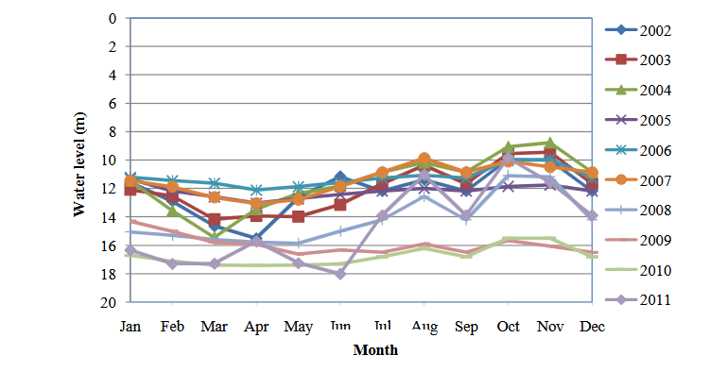

Figure 1: Monthly variation in groundwater level of Nawabganj Upazila for the years 2002-2011

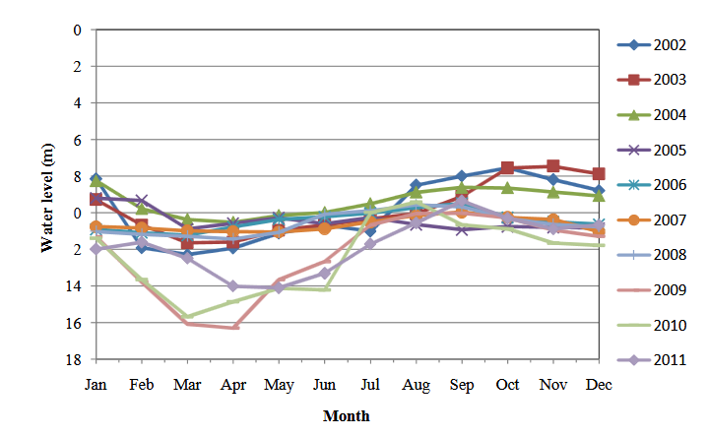

Figure 2: Monthly variation in groundwater level ofShibganj Upazila for the years 2002-2011

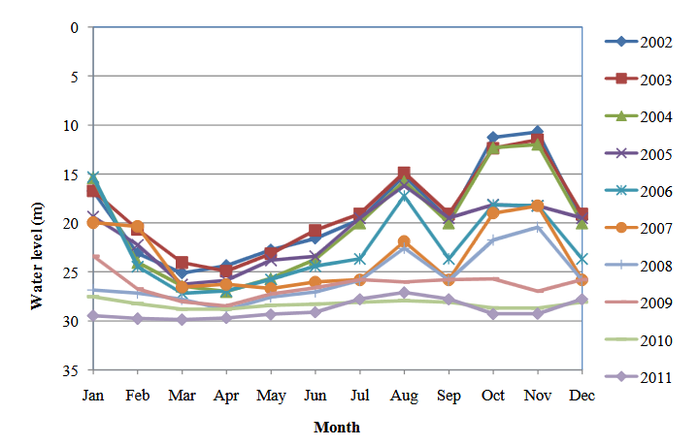

Figure 3: Monthly variation in groundwater level of Nachole Upazila for the years

2002-2011.



Figure 4: Monthly variation in groundwater level of Gomastapur Upazila for the years

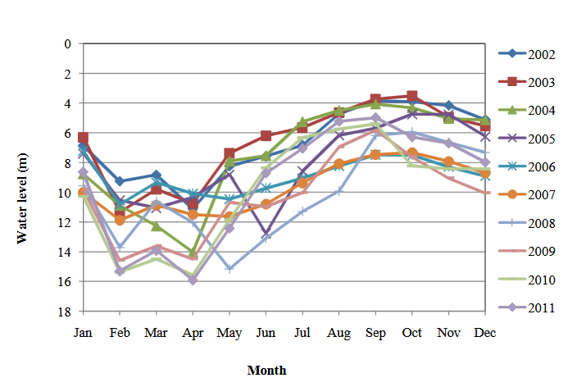

Figure 5: Monthly variation in groundwater level of Bholahat Upazila for the years 2002-2011

Yearly maximum and minimum groundwater level graphs have been prepared by taking the highest and lowest groundwater table and shown in Figures 13-14. The water level varies from 17.51 m to 8.6 m during 2002-2011 at Nawabganj Upazila. The maximum depletion of water level was found to be 17.51 m in 2010 and minimum was 8.60 m in 2004. In Shibganj Upazila, the water level varies from 8.47 m to 0.9 m. The maximum depletion of groundwater level was found to be 8.47 m in 2011 and the minimum was about 1.0 m 2004. The groundwater level varies from 29.38 m to 9.6 m at Nachole Upazila for the same period was observed. The maximum water level was observed to be 29.5 m in 2010 and the minimum was 10.0 m in 2002. In Gomastapur Upazila, the water level fluctuated from 16.32 m to 7.0 m. The maximum water level was 16.5 m in 2009 and minimum was 7.0 m in 2002. The study also observed groundwater level fluctuation at Bholahat Upazila through the years 2002-2011. The groundwater level varies from 16.0 m to 3.5 m. The maximum water level was observed to be 16.0m in 2011 and minimum was 3.5 m in 2002

Table 2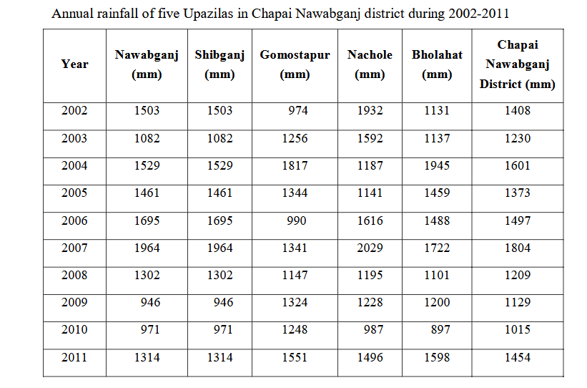

The maximum annual rainfall recorded was 1804 mm in 2007. Since then, rainfall was gradually decreasing for consecutive three years, but it was increased 439 mm in 2011 from 1015 mm recorded in the previous year. The results show that Nachole Upazila received the highest rainfall 2029 mm in 2007 and Bholahat Upazila received the lowest rainfall 897 mm in 2010 during the study period of the area. The average rainfall received in Chapai Nawabganj district was 1372 mm during 2002-2011 (not shown in the table 2). A report showed that the rainfall recorded was about 1738 mm in 1981 and 798 mm in 1992 in the Baring area suggesting yearly rainfall variations (Banglapedia Website). The rainfall data of the study also show a wide variation of rainfall depending on area and yea.

Table 3

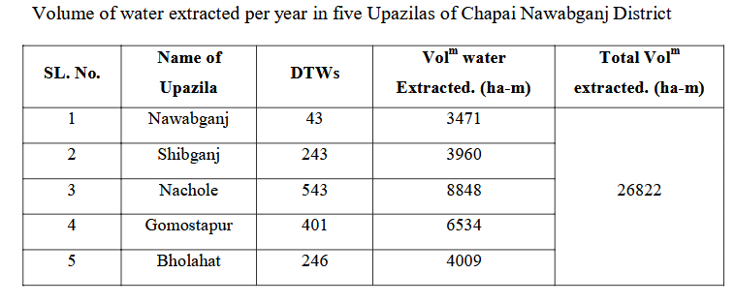

**4.2 Geo-chemistry of groundwater**

4.2.1 Geochemical processes of groundwater

The rock-water interaction generally includes chemical weathering of rock forming minerals, dissolution-precipitation of carbonates, and ion exchange between water and clay minerals. The abundance and distribution of elemental ions such as Ca2+, Mg2+, Na+, K+, HCO3-, SO42- and Cl- in the water are dependent on erosion and chemical weathering of the rocks in the source area. Interaction between groundwater and its surrounding minerals in the alluvium may be the main process for the observed chemical characteristics of groundwater in the study area.

4.2.2 Fecal Coliform (FC)

Fecal coliform (FC) was not found in any collected DTWs water samples in the study area indicating its suitability for all purpose uses. The analysis results suggest that the concentration of TH, HCO3, Ca, Na, K, Mg, and Fe, ions in water were the cause of weathering of aquifer materials. So, groundwater of Chapai Nawabganj district shows a wide range of characteristics in terms of physical, chemical and microbial parameters during two seasons. The study observes that the quality of groundwater was very much suitable for irrigation and domestic purposes.

**4.3 Impact of Groundwater over Withdrawal on Environment**

Groundwater is the major source of freshwater supply in many areas of south-east Asia. The water is being pumped from beneath the ground faster than it is being replenished through rainfall in many places. The result is depleting water tables, empty wells, higher pumping costs, quality deterioration and, in coastal areas, the intrusion of saltwater from the sea which degrades the groundwater. Irrigation is the main cause of groundwater overexploitation in Barind area threatens sustainable resource management. The study results identified the groundwater extraction of Chapai Nawabganj district for irrigation as a critical environmental concerned. The study observed the below average rainfall has another causes of groundwater depletion due to lower recharge and thus further aggravated the situation in the study area. The key impediments to potentiality of groundwater have been identified as over exploitation of groundwater use in Boro rice cultivation in the area. Groundwater for irrigation use in Barind tract is increasing day by day. The quality of groundwater primarily depends on ground-water resources that are used for public and domestic supply. Groundwater over exploitation has increased the chance to deteriorate the water quality. The introduction of contaminants into groundwater aquifer through human or natural activities deteriorated the water quality. The most significant diffuse contaminant of groundwater in Barind tract is arsenic due groundwater pumping which releases As (V) and As(III) on pyrite in continuously anoxic environments or on pyrite in intermittently oxic/anoxic environments (Sun et al., 2012). Liu et al. (2003) reported the water pumped from deeper aquifer has introduced excess dissolved oxygen that in turn oxidizes the original immobile minerals, releasing arsenic and other ions.

The runoff was estimated from the rainfall and the results show the maximumestimated runoff was 304 mm found in 2007 at Nachole Upazila and the minimum was 121 mm in 2003 at Shibganj Upazila during the study period (Table 4). Without any exception, runoff was gradually decreasing in the study area for consecutive three years since 2007, but it was increased in all Upazilas of the of the district in 2011 as expected due to higher rainfall received this year.

Table 4

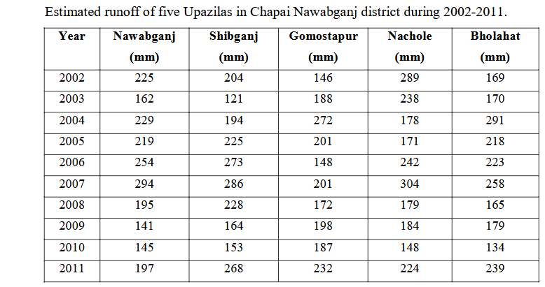

The infiltration of the study area was calculated using evapotranpiration (ET) data (Appendix-3). The estimated infiltration results of Chapai Nawabganj district illustrate that the highest infiltration was 1700 mm found in 2007 at Nachole Upazila and the minimum was 657 mm found in 2003 at Shibganj Upazila (Table 5). In the study area, a decreasing trend in infiltration was observed for consecutive three years in the study since 2007, but it was increased in 2011 in all Upazilas due to higher rainfall received this year. An overall fluctuation was observed in estimated infiltration throughout the study period

Table 5

.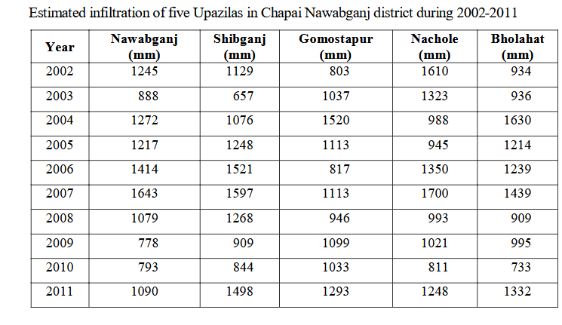

CHAPTER FIVE

SUMMARY, RECOMMENDATION & CONCLUSION

**5.1 Summary**

This research program has considered rainfall, water level fluctuation and drilling log data, and water quality parameters of five Upazilas in Chapai Nawabganj district under the Barind area in view of maintaining sustainable irrigation water supply to achieve food security as well as water resource management. The study area consisted of five Upazilas in the Barind area, namely Nawabganj, Shibganj, Nachole, Gomastapur and Bholahat. The study largely considered secondary data collected from different organizations and five boring log samples were collected from five Upazilas of Chapai Nawabganj district. A total of 50 representatives deep tubewells (DTWs) water samples were collected from 5 selected locations of each Upazila during the month of March (pre-monsoon) and October (post-monsoon), 2014. The experimental data were statistically analyzed using various software and the results were discussed to interpret the geochemical characteristics, water type, and water quality.

The study was attempted to understand the fluctuation of groundwater table, potentiality, water quality, and as well as to assess storage capacity. The study results show that the maximum water tables depletion were found between February to May and elevated water tables were found throughout September and October as expected due to post-monsoon groundwater level. The study results also illustrate the maximum water level recorded was about 30 m below the surface at Nachole Upazila in 2010 and minimum water level recorded was about 1.0 m below the surface at Shibganj Upazila in 2004. In Nawabganj Upazila, the maximum depletion of water level was found to be 17.51 m in 2010 and minimum was 8.60 m in 2004. In Shibganj Upazila, the maximum depletion of groundwater level was found to be 8.47 m in 2011 and the minimum was about 1.0m 2004. In Nachole Upazila, the maximum water level was observed to be 29.5 m in 2010 and the minimum was 10.0 m in 2002. In Gomastapur Upazila, the maximum water level was 16.5 m in 2009 and minimum was 7.0m in 2002. In Bholahat Upazila, the maximum water level was observed to be 16.0 m in 2011 and minimum was 3.5 m in 2002.

**5.2 Conclusion**

The results illustrate that the highest groundwater depletion was about 29 m found at Nawabganj Upazila in 2010 and the lowest was about 5m at Shibganj in 2003. A 10-year rainfall data of the district shows that the maximum annual rainfall recorded was 1804 mm in 2007. Since then, rainfall was gradually decreasing for consecutive three years, but it was increased 439 mm in 2011 from 1015 mm recorded in the previous year. The results show that Nachole Upazila received the highest rainfall (2029mm) in 2007 and Bholahat Upazila received the lowest rainfall (897mm) in 2010 during the study period of the area. The average rainfall received in Chapai Nawabganj district was 1372 mm during 2002-2011. The runoff was estimated from the rainfall and the results show the maximum estimated runoff was 304 mm found in 2007 at Nachole Upazila and the minimum was 121 mm in 2003 at Shibganj Upazila during the study period. Without any exception, runoff was gradually decreasing in the study area for consecutive three years since 2007, but it was increased in all Upazilas of the district in 2011 as expected due to higher rainfall received.

The estimated infiltration results of Chapai Nawabganj district in Barind area illustrate that the highest infiltration was 1700 mm found in 2007 at Nachole Upazila and the minimum was 657 mm in 2003 at Shibganj Upazila. In the study area, a decreasing trend in infiltration was observed for consecutive three years in the study since 2007, but increased amount was found in 2011 in all Upazilas due to higher rainfall received this year. The amount of runoff and infiltration were varied with rainfall received as expected. The highest annual rainfall received was 1793 mm in 2007 and the lowest was 1025 mm in 2010 in the district. The results show a good relation among the parameters indicating that the higher amount was the rainfall, the higher amounts were the estimated runoff and infiltration. A good trend of water table fluctuations of Chapai Nawabganj district was found during 2002 to 2011.

The results illustrate that the overall water table showed the minimum water level was found in 2004 and maximum in 2011. The graphs show wave like fluctuation curves, where the highest depletion occurred during March-April and then the water table moved upward direction slowly and reached at minimum level during September-October and again slowly depleted until rain started in May. The study results reveal that a good relation between rainfall and water table fluctuations was observed where the groundwater table was recharged through the rainfall. The overall yearly water table declining trend indicate that unsustainable withdrawal of groundwater for irrigation and domestic purposes would be played a vital role in water table depletion in the study area. Fluctuation of groundwater level was different in magnitude depending on the extraction and recharge in different locations. Specific yield of the five Upazilas were determined and the values were found around 10 (%) which indicate good permeability of the areas, except Bholahat Upzila, where the value was 8.4 (%) indicating low permeability. The storage capacity of the five Upazilas in Chapai Nawabganj district was estimated using the area, the average fluctuation and specific yield storage of groundwater and the results illustrate that Nachole Upazila has comparatively a large storage volume, i.e., 49,305 ha-m, but the other Upazilas have a storage capacity between 8000 to 18000 ha-m. The storage capacity of the five Upazilas was followed the order: Nachole>Nawabganj>Shibganj>Gomastapur>Bholahat.

**Recommandation**

There is considerable scope for improving groundwater potentiality through assessing the water table fluctuation and analyzing the water quality parameters. Therefore, further research works and study would be conducted considering a 30-year groundwater fluctuation data on the entire Barind area and the analysis of water quality parameters for pre-monsoon, monsoon and post-monsoon covering two years for better understanding of the groundwater potentiality and sustainable water of the area

References:

[1]. Aziz, M. A. et al. (2015). Groundwater Depletion with Expansion of Irrigation in  
Barind Tract: A Case Study of Rajshahi District of Bangladesh. International Journal  
of Geology, Agriculture and Environmental Sciences, Volume (3 Issue)

[2]. Mostafa, M. G., Hasan , M.R. and Rahman, N (2018). Groundwater Depletion and its  
Sustainable Management in Barind Tract of Bangladesh. Research Journal of  
Environmental, Sciences ,12(5), pp.247-255.

[3]. Hasan, M. R. (2014). Evaluation of Groundwater Potentiality and Exploitation in  
Barind Area and Its Impact on Environment. Institute of Environmental Science  
(IES), RU.

[4]. Bhattarai ,N. et al. (2021). The impact of groundwater depletion on agricultural  
production in India. Environmental Research Letters, Volume (16) ,pp.085003.  
[5]. Sayre, S.S. and Taraz, V. (2018). Groundwater depletion in India: Social losses from  
costly well deepening, Journal of Environmental Economics and Management

[5].BGS and MML, (1998). Ground Water Studies for Arsenic Contamination in Bangladesh. British Geological Survey, Mott-MacDonald Ltd., UK.

[6].Bhardwaj, V., Singh, D. S., and Singh, A. K., (2010). Hydro-geochemistry of groundwater and anthropogenic control over dolomitization reactions in alluvial sediments of the Deoria district: Ganga plain, India. Environmental Earth Science. 59, 1099-1109.

[7].BMDA, (2000). Impact Evaluation of Barind Integrated Area Development Project (BIADP), Final Report July.

[8].BMDA,( 2006). “Borandro Authority Past-Present,” BMDA Rajshahi, p. 35.

[9].Brown, L. & Halweil, B., 1998. China’s water shortage could shake world food security. Wld. Watch Mag.

[10].Burke, J. J., (2002). Groundwater for irrigation: productivity gains and the need to manage hydroenvironmental risk. In R. Llamas & E. Custodio, eds. Intensive use of groundwater challenges and opportunities. 478 pp. Abingdon, U.K., Balkema.

[11].Chadha, D. K., (1999). A proposed new diagram for geochemical classification of natural waters and interpretation of chemical data. Journal Hydrogeol. 7, 431-439.

[12].Chakraborti, D., Rahman, M. M., Das, B., Murrill, M., Dey, S., Mukherjee, S. C., Dhar, R. K., Biswas, B. K., Chowdhury, U. K., Roy, S., Sorif, S., Selim, M., Rahman, M. and Quamruzzaman, Q., (2002). Status of groundwater arsenic contamination in Bangladesh: a 14-year study report. Water Res. 44 (19), 5789-5802.

[13].Chakravarty, S., Dureja, V., Bhattacharyya, G., Maity, S. and Bhattacharjee, S., (2010). Removal of arsenic from groundwater using low cost ferruginous manganeseore. Water Res. 36 (3), 625-632.

[14].Chaudhary, B. S., Manoj Kumar, A. K., Roy and Ruhal, D. S., (1996). “Application of Remote Sensing and Geographic Information Systems in Groundwater Investigations in Sohna Block, Gurgaon District, Haryana INDIA”, International Archives of Photogrammetry and Remote Sensing, Volume XXXI, Part B6, Vienna, pp 18-23.

[15].MacDonald, A. M. and Davies, J., (2000). A brief review of groundwater for rural water supply in sub-Saharan Africa. British Geological Survey technical report WC/00/33.  
[16].MacDonald, A. M., Calow, R. C., Nicol, A. L., Hope, B. and Robins, N. S.,( 2001). Ethiopia: water security and drought. British Geological Survey technical report WC/01/02.  
[16].Masiyandima, M., and Giordano, M. 2007. Sub-Saharan Africa: opportunistic exploitation. In M. Giordano & K. Villholth (Eds.), The agricultural groundwater revolution: opportunitiesand threats to development.Wallingford: CABI 79–99 pp.  
[17].Matin, I., (1991). Ground Water Extraction and Its Impact of the Environment-A Case Study of Barind Tract in Bangladesh. In Environmental Degradation and Developmental Strategies in India. Ashish Publishing House, 8/81, Punjabi Bagh, New Delhi-110 026, 68 p.  
[18].McCarthy JJ, Canziani OF, Leary NA, Dokken DJ, White KS (2001). Climate change 2001: impacts, adaptation, and vulnerability. Contribution of Working Group II to the Third Assessment Report of the Intergovernmental Panel on Climate Change. Cambridge University Press, Cambridge  
[19].McMahon, P. B., Dennehy, K. F., Bruce, B. W., Gurdak, J. J., and Qi, S. L., (2007).  
Water-quality assessment of the High Plains aquifer, 1999–2004: U.S.Geological Survey Professional Paper 1749, 136 p.  
[20]. Meng, X., George, P. K., Christos, C. and Sunbaek, B.,( 2001). Treatment of arsenic iBangladesh well water using a household co-precipitation and filtration system.  
Water Res. 35 (12), 2805-2810.  
[21].Milly, P. C. D., Dunne, K. A., and Vecchia, A. V., (2005). Global pattern of trends in streamflow and water availability in a changing climate: Nature, v. 438, no. 7066, p. 347–350.  
[22].Mishra, A. K. Arya, M. and Mathur, R., 2011. Assessment of pre-monsoon and post- Monsoon ground water quality with special reference to fluoride concentration in Narwar, Shivpuri, Madhya Pradesh, India. J. of Environmental Research, and Development. 6 (1), 77-81.

[23].Reynolds, R.,( 1987). Diffusivity of a glacial-outwash aquifer by the flood wave- response technique, Ground Water, 25 (3), 290–299. Rosenzweig, C., Hillel, D., 1998. Climate change and the global harvest: potential impacts of the greenhouse effect on agriculture. Oxford University Press, Oxford

[24].Rowe, P., (1960). An equation for estimating transmissibility and coefficient of storage from river-level fluctuations. Journal of Geophysical Research, 65 (10), 3419– 3424.

[25].RWASA (Rajshahi Water Supply and Sewerage Authority), 2013. Available from http//: www.rajshahiwasa.org.bd/details/menudetail/10.(access 28 June 2013)

[26].Nickson, R., McArthur, J., Burgess, W., Ahmed, K. M., Ravenscroft, P. and Rahman, M., (1998). Arsenic poisoning of Bangladesh groundwater. Nature. 395, pp. 338.

[27].Nisi, B., Buccianti, A., Vaselli, O., Perini, G., Tassi, F. and Minissale, A ( 2008). Hydrogeochemistry and strontium isotopes in the Arno River Basin (Tuscany, Italy): constraints on natural controls by statistical modeling. J. Hydrol. 360, 166-183.

[28].Novikov, Y. V., Plitman, S. I., Levin, A. I. and Noarov, Y. A., (1983). Hygienic regulation for minimum magnesium levels in drinking water (In Russian). Gig. Sanit. 48 (9), 7-11.

[29].Ojima, D., Garcia, L., Elgaali, E., Miller, K., G. F. K. T., Lackett J., (1999). Potentialclimate change impacts on water resources in the Great Plains. J Am Water Resour Assoc 35:1443–1454

[30].Paige, G. B., J. J. Stone, J. Smith, and J. R. Kennedy. (2003). The Walnut Gulch rainfall simulator: A computer‐controlled variable‐intensity rainfall simulator. Applied Eng. in Agric.20 (1): 25‐31.

[31].Sadashivaiah, C., Ramakrishnaiah, C. R., and Ranganna, G., (2008). Hydrochemical analysis and evaluation of groundwater quality in Tumkur taluk, Karnataka state, India. Int. J. Environ. Res. Public Health. 5 (3), 158-164.

[32].Sampal, P.( 2000). Deep Trouble: The Hidden Threat of Groundwater Pollution. WorldWatch Paper 154. 55pp.